**SE2 Week 1 Homework- Nguyen Duy Thai Son- 3C17**

**Screenshot of MySql server before running:**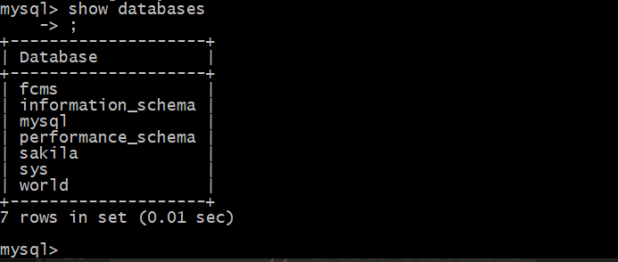

**Creating a new database named “studentdb” and creating Student table:**

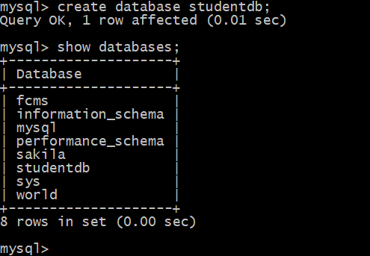

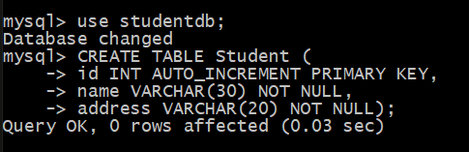

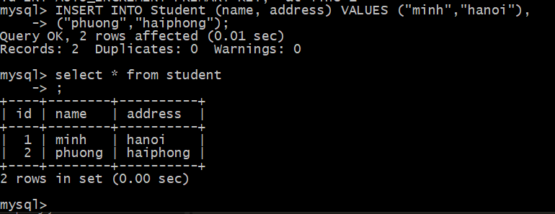

**Sucessful connection inside Eclipse:**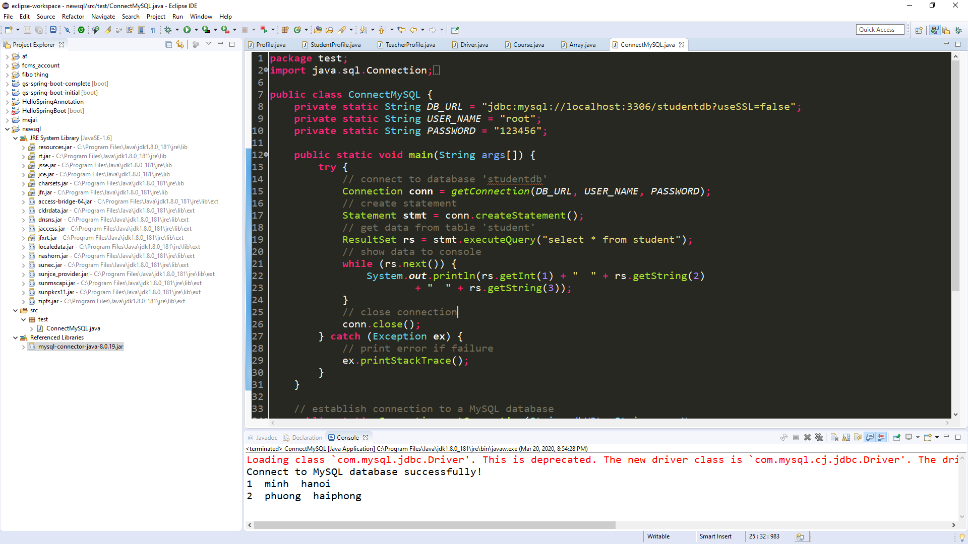

**Thank you for reading!**